Report Notification
Overview : Report Notification allows you to automatically send business reports to an email address at a scheduled time. You can choose the report type, set the notification time, enter the recipient's email, and enable or disable the notification. This feature helps you receive important business reports regularly without downloading them manually.

Path : billing.petpooja.com >> Reports >> Report Notifications.

outletwise_link : https://billing.petpooja.com/custom_reports/report_notifications/
Step 1 : Billing.petpooja.com in Steps to reach Report Notifications : Open your browser and go to billing.petpooja.com.
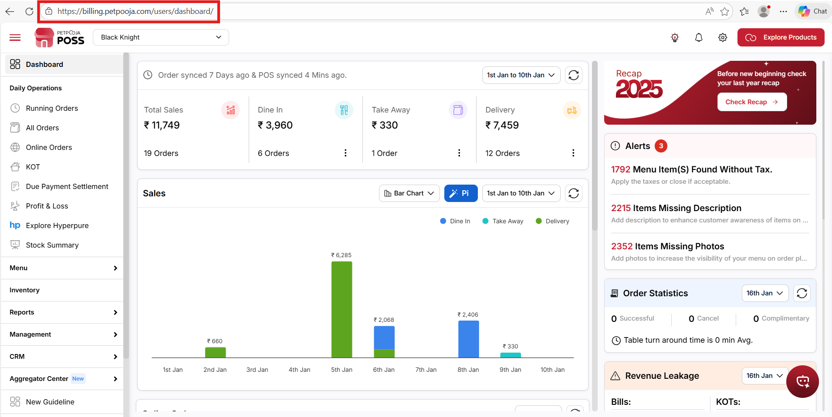
{ Image Name: PetPooja Dashboard,
Description: The image shows the PetPooja "Outlets Statistics" dashboard accessed via a web browser, as indicated by the URL. Here is an image of step 1 Billing.petpooja.com in Steps to reach Report Notification }
Step 2 : Reports in Steps to reach Report Notifications : Click on the Reports section from the dashboard.
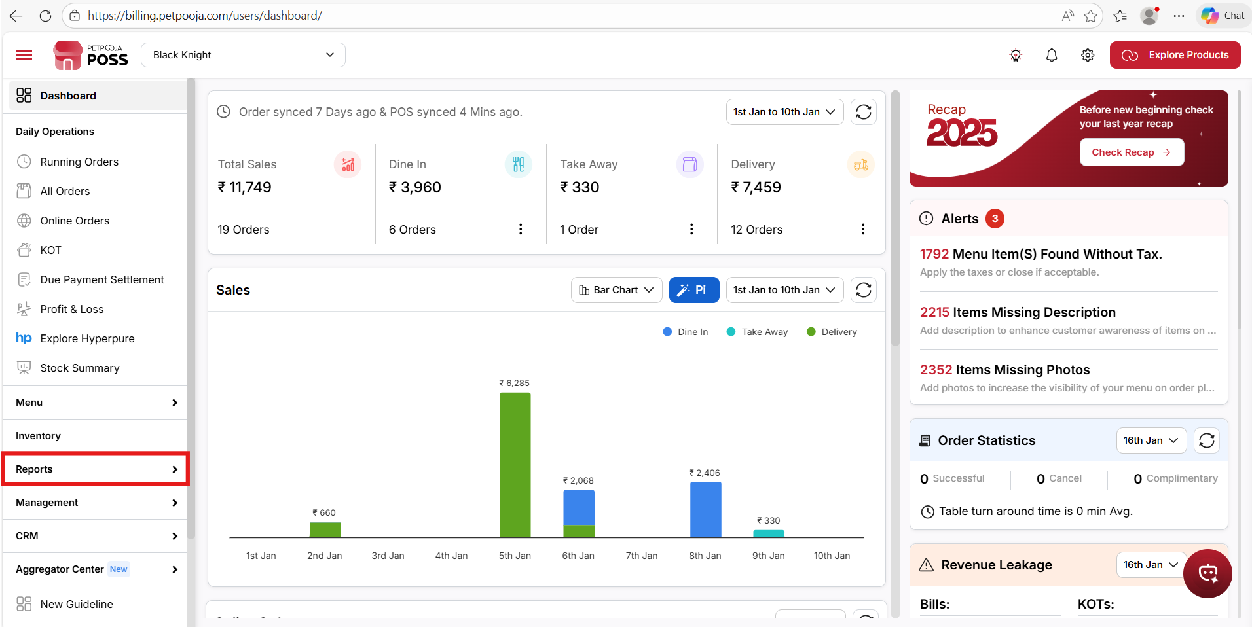
{ Image Name: PetPooja Reports,
Description: The image shows the PetPooja Reports dashboard, highlighting the "Reports" section.Here is an image of step 2 Reports in Steps to reach Report Notification }
Step 3 : Report Notifications in Steps to reach Report Notifications : Inside the Reports section, click on Report Notifications.
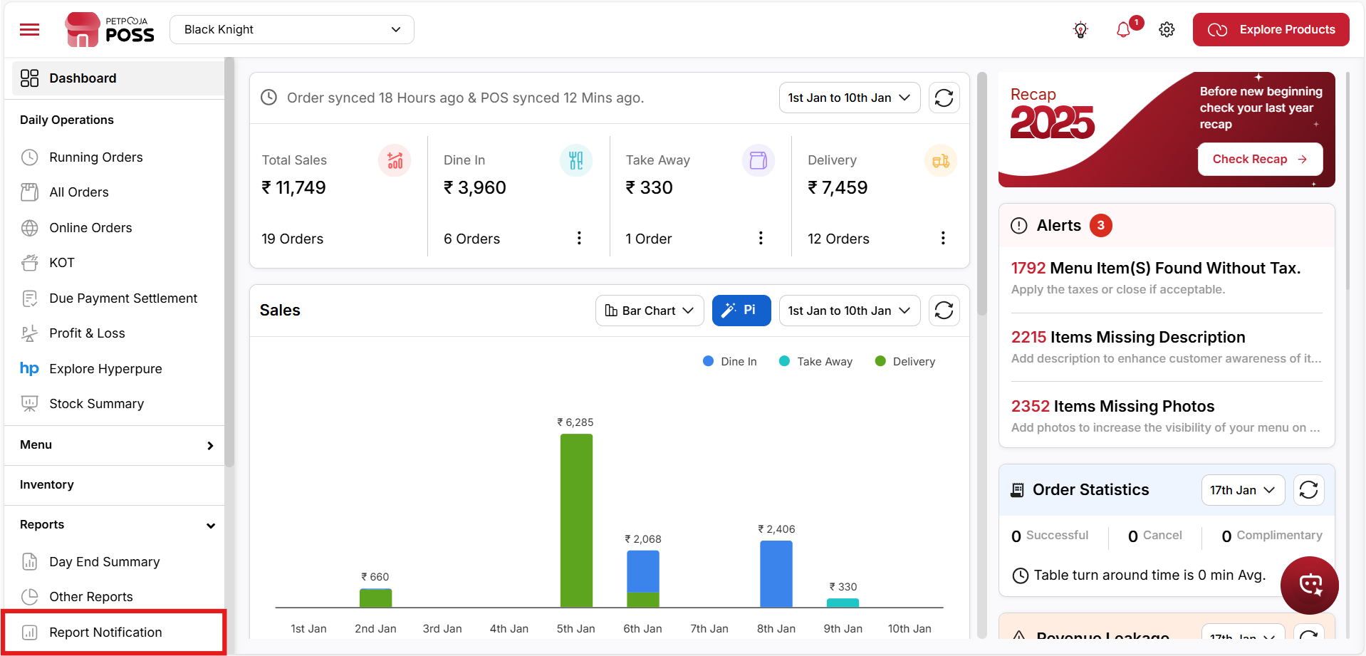
{ Image Name: PetPooja Report Notifications ,
Description: The image displays the "Report Notifications" section within PetPooja's Reports menu.Here is an image of step 3 Reports in Steps to reach Report Notification }

Report Notification Settings - Functionality Overview (Report Notification):
outletwise_link : https://billing.petpooja.com/custom_reports/report_notifications/

Add Report Notification (Report Notification Settings)
- Click the " + Add Report Notification" button to create a new report notification.
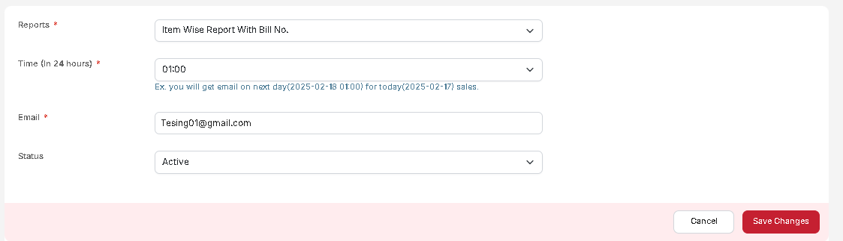
{ Image Name: PetPooja Report Notification,
Description: Here is an image displays the settings for a report notification }

Steps to Add a Report Notification in Petpooja (Report Notification Settings) :
outletwise_link : https://billing.petpooja.com/custom_reports/report_notifications/

- Select Report Type (Report Notification Settings) :
- Choose the type of report from the Reports dropdown.
- Example:
  - Item Wise Report With Bill No
  - Restaurant Daily Report
  - Executive Sales Summary Report
  - Payment Wise Order Summary
- Set Notification Time (Report Notification Settings) :
- Select the time in 24-hour format from the Time dropdown.
- Example: "00:00" means the report will be sent at midnight for the previous day's sales.
- Enter Email Address (Report Notification Settings) :
- Enter the email where the report should be sent.
- This is a required field.
- Choose Status (Report Notification Settings) :
- Select Active or Inactive from the Status dropdown.
- If set to Active, the report will be sent as per the schedule.
- Save or Cancel (Report Notification Settings) :
- Click "Save Changes" to confirm and save the notification.
- Click "Cancel" to discard changes.
Action Button (Report Notification Settings) :
outletwise_link : https://billing.petpooja.com/custom_reports/report_notifications/
- Deactivate Notification: Click the "Action" button and select "Inactive" to disable a specific report notification.
(Report Notification) Note: You cannot add more than 4 report notifications in this section.

